**Migrate image from host to another**

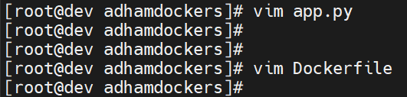

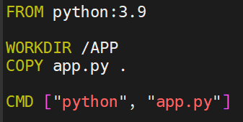

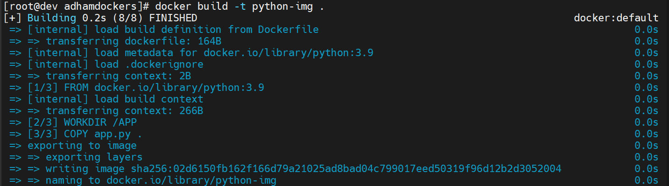

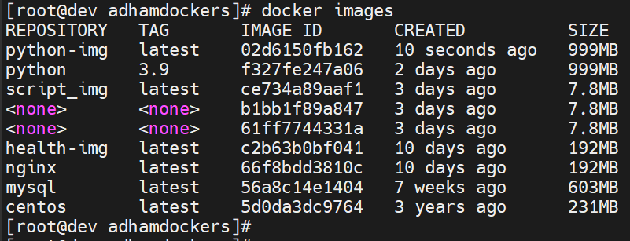

**Save image as tar file to be ready to transfer**

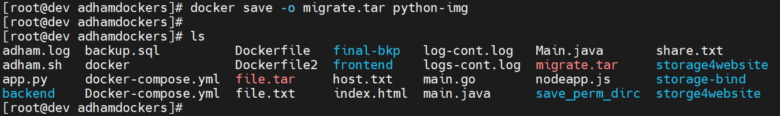

**Transfer tar file(image) to target host**

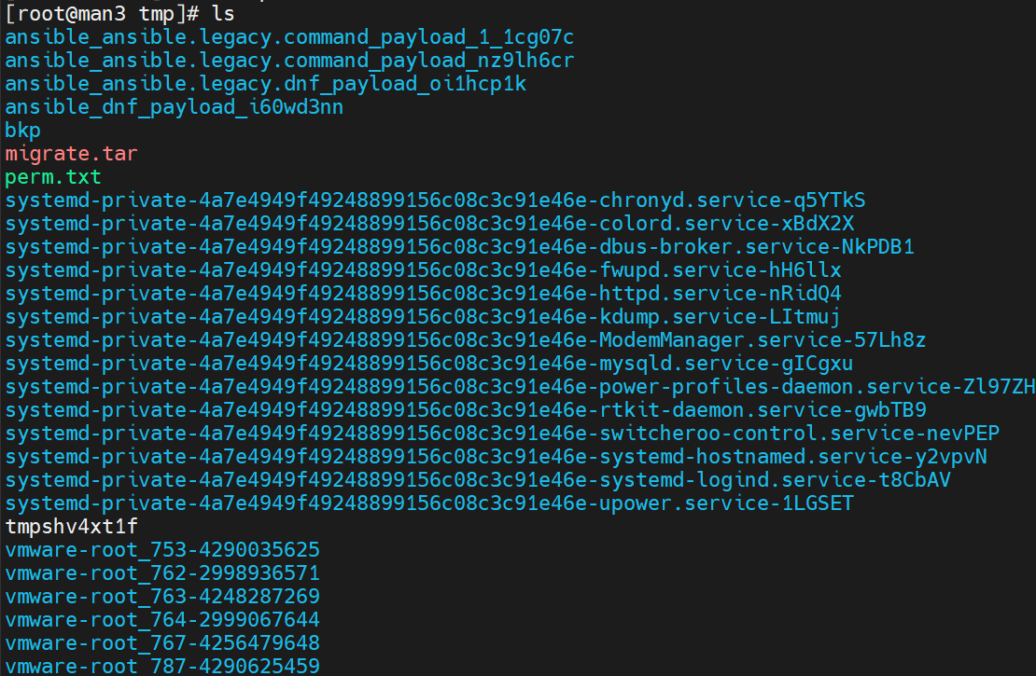

**Import the image from tar file**

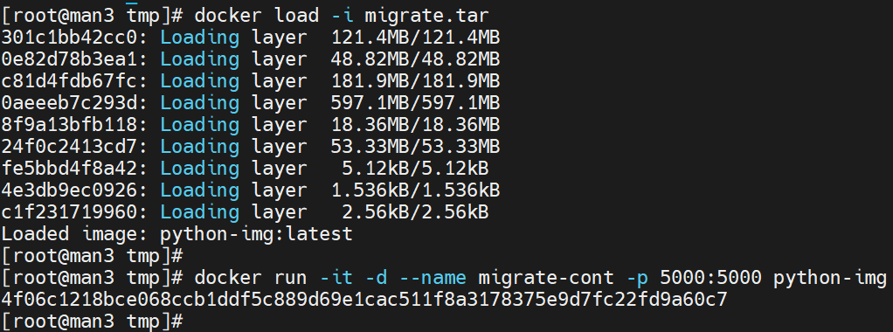

**Build container from image’**

